**Front End Programming**

**Name:- Nandini Vaish Section/Group:- 6-B**

**UID:- 22MCA20582 Date of Performance:- 21/12/2022**

**Experiment No. 3.1**

**Task to be done:**

**Experiment No. 1:-** Create a Time Table using Bootstrap, CSS and HTML.

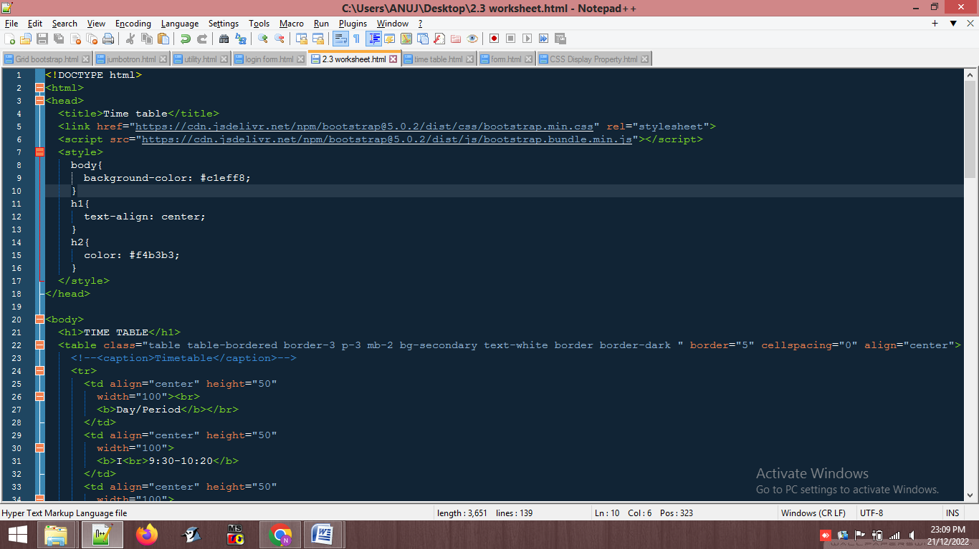

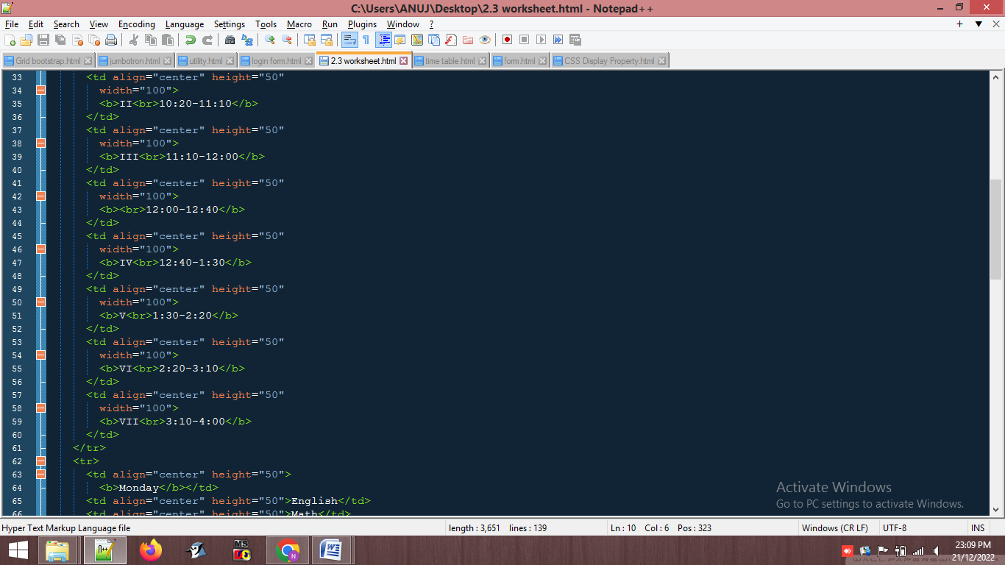

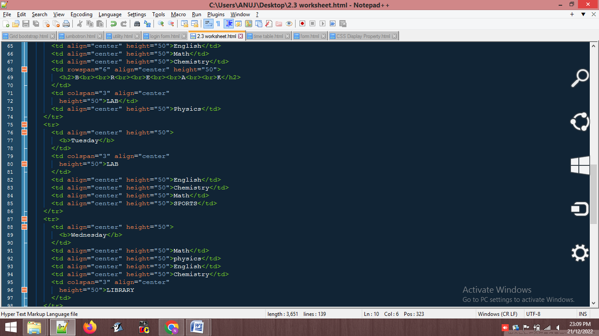

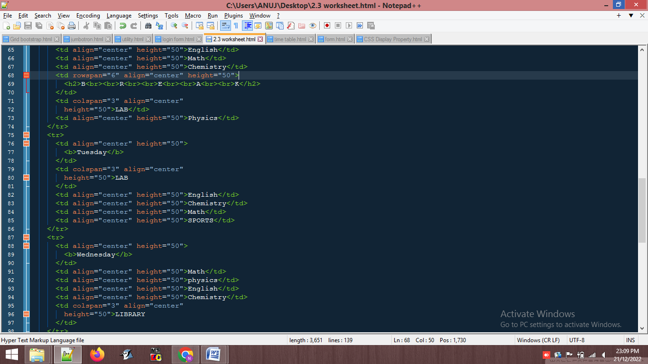

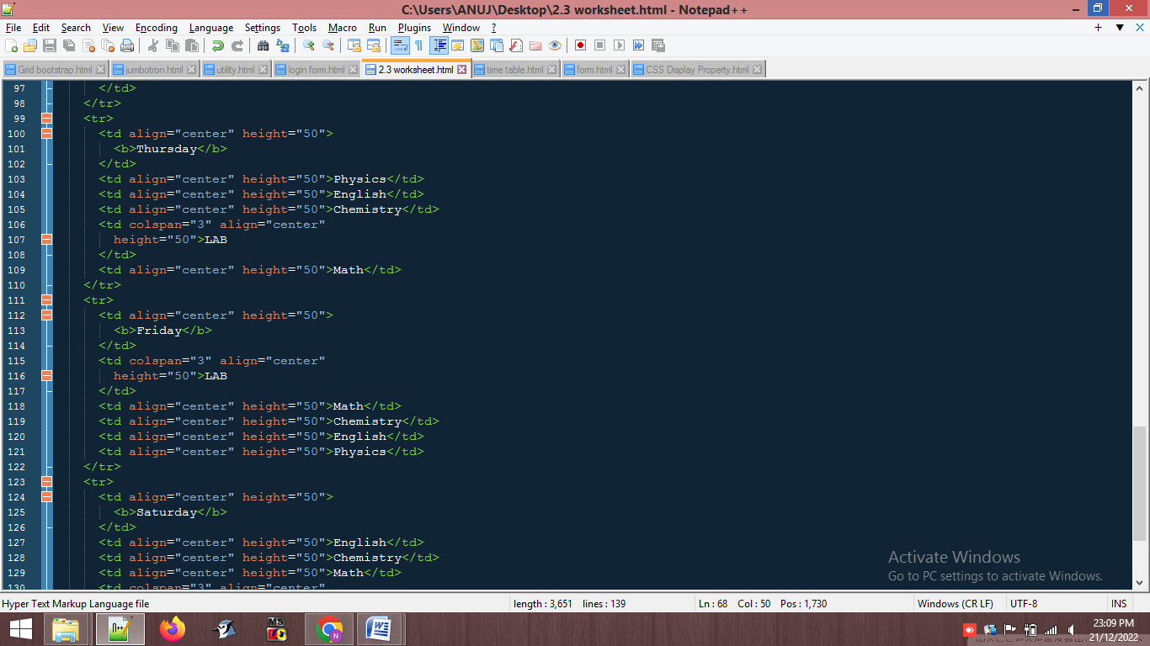

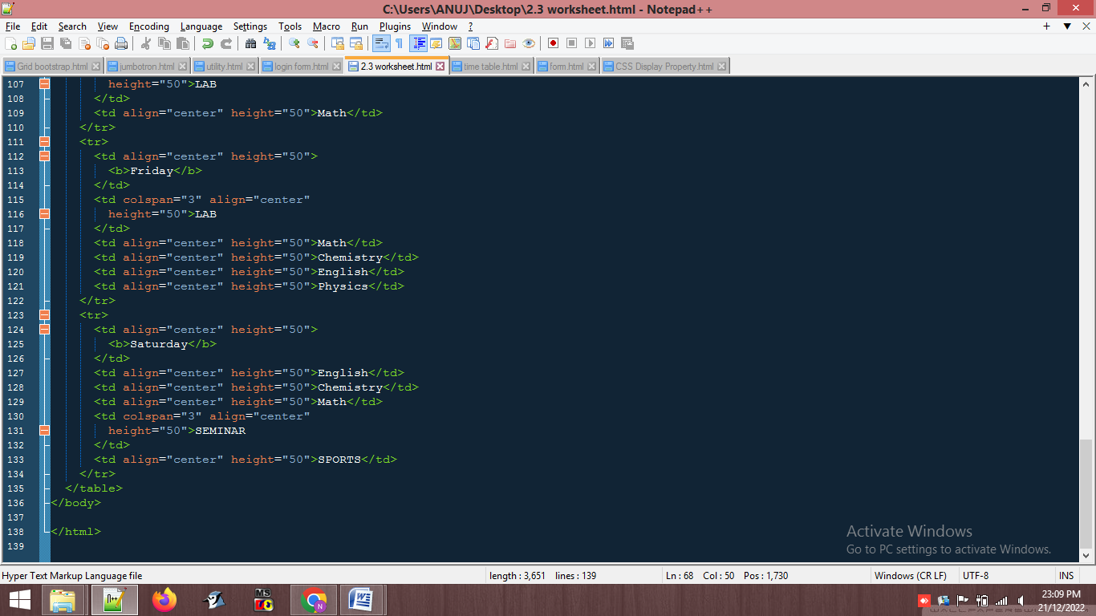

**Output :-**

